UNIVERSITY OF TECHNOLOGY

School of Computing and Information Technology

Presented in Partial Fulfillment of the Course Requirement
Object-Oriented Programming using C++

“National Library Reference/User Database”

Group Members:
Xavier Lowe – 0802488
Dale McFarlane – 0801422
Robert Campbell – 0701334
Dyonne Duberry – 0802189
Audley Gordon – 0802218

Lecturer: D. White
Tutor: Tyrone Edwards
Group: BSC2D
Main Menu

Upon running the executable file, the user will be presented with a menu as displayed in the image below.

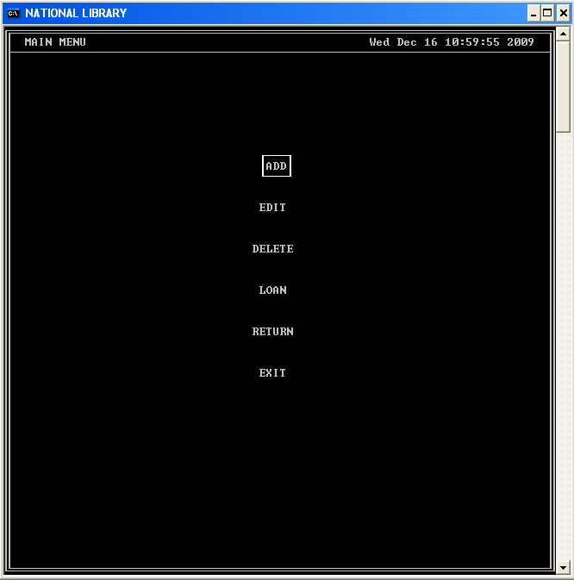

The user will be able to select any item from the menu by navigation it with the navigation keys (up, down and tab). The user selects an item by pressing the “Enter” key when the desired item is hilighted.

Add Menu
Upon selecting “ADD” from the “Main Menu”, the user will be presented with the option of adding 1 of three types of reference materials as illustrated below.

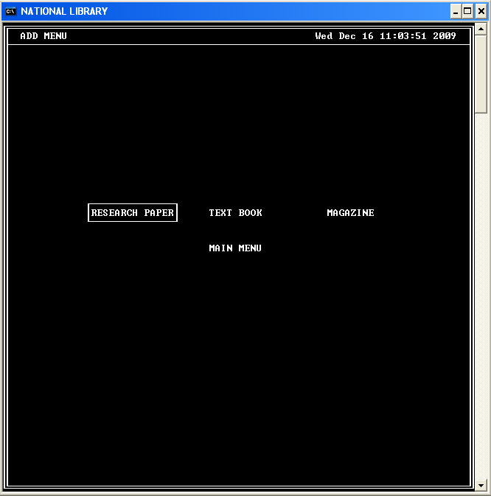

The user can navigate this menu using the navigation keys (up, down, left, right and tab).

Add a reference Material
After selecting a reference material type (Research Paper, Text Book, Magazine) from the “Add Menu”, the user will be presented with a form to enter the details of the reference material as illustrated below.

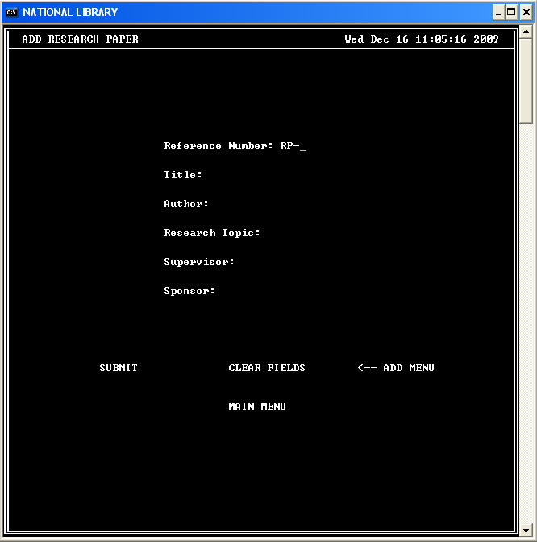

After completing the form:

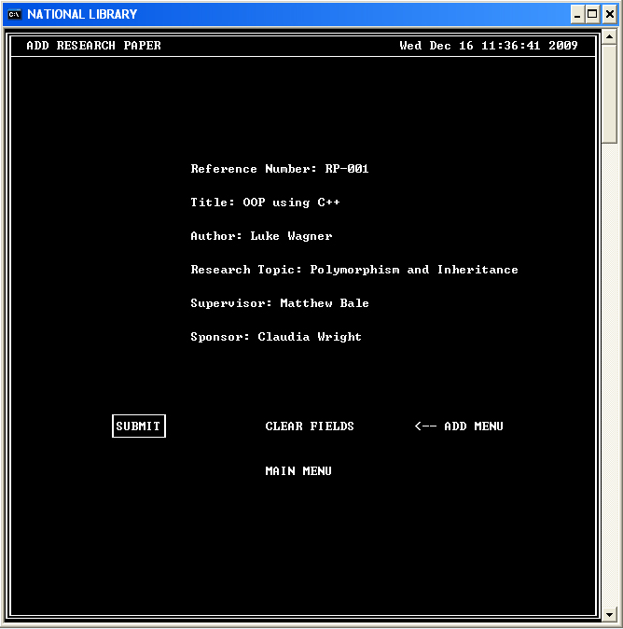

The user will be allowed to “Submit” to save the data, “Clear Fields” which resets the form, “Add Menu” which will take them back to the “Add Menu” where they can choose to add a different Reference Material or “Main Menu” which will take them back to the Main Menu.

Upon selecting “Submit”, the user will be presented with an option of confirming that they want to store the data (SAVE MATERIAL) or “Cancel” as shown below.

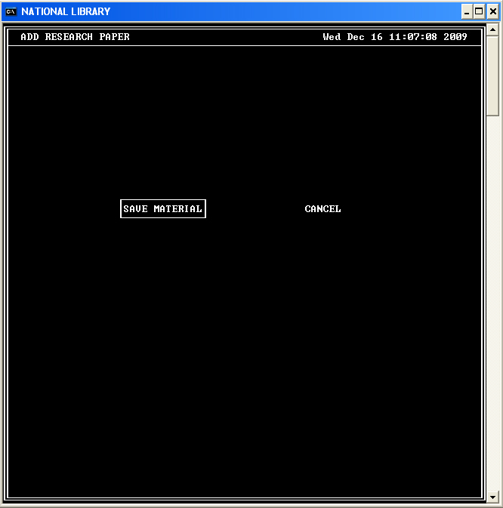

If the user selects “SAVE MATERIAL”, the data will be saved and the following screen will be presented to the user.

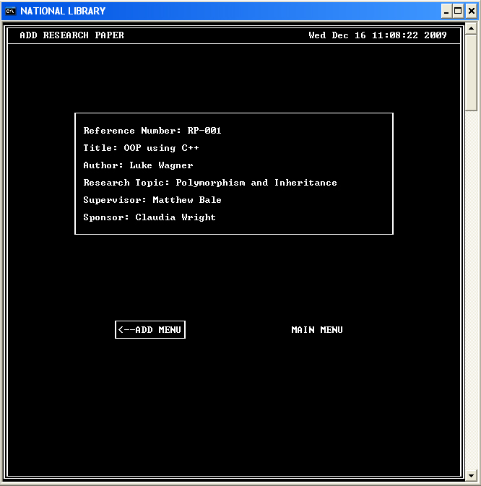

The user will then have the option of returning to the “Main Menu” by selecting “MAIN MENU” or to add another reference material by selecting “ADD MENU”.
Edit Menu

By “EDIT” from the “Main Menu”, the user will be presented with a form to enter the reference number of the material they would like to edit as illustrated below.

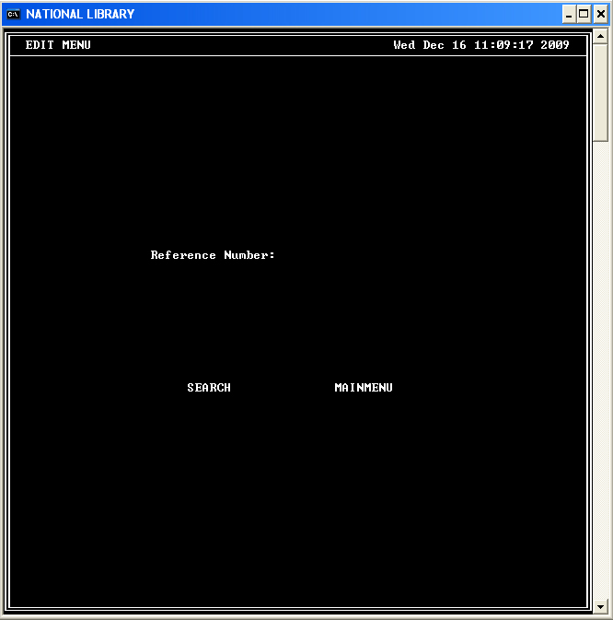

After entering a valid Reference number as shown below:

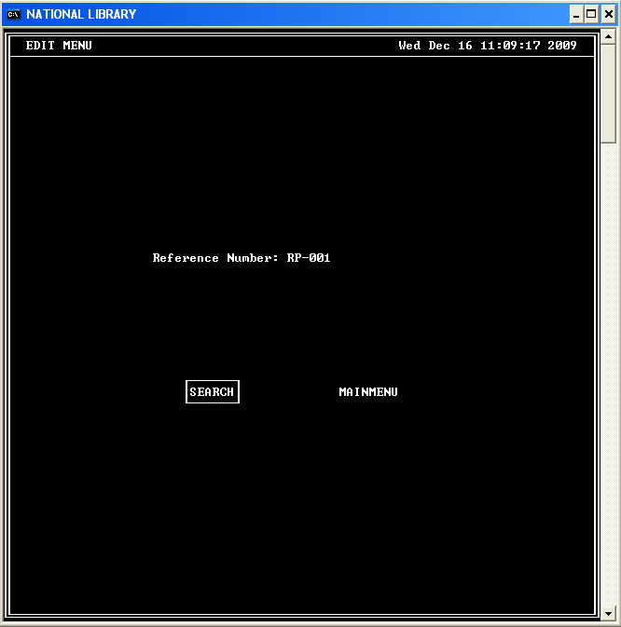

The user will be able to search for the material or return to “Main Menu”.

If the user selects “SEARCH”, if the data is found a screen with a form to edit the information along with the current data stored on the file is displayed.

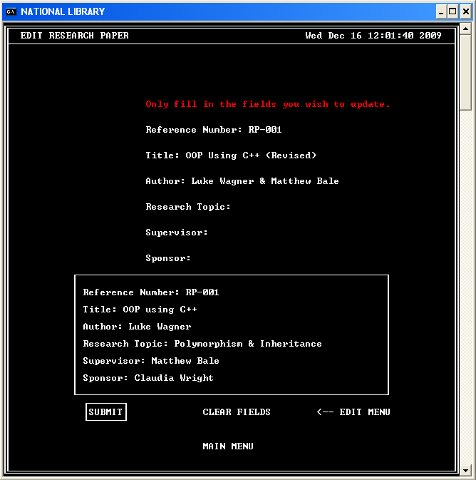

After selecting “SUBMIT”, the user can then confirm the changes or cancel the operation.

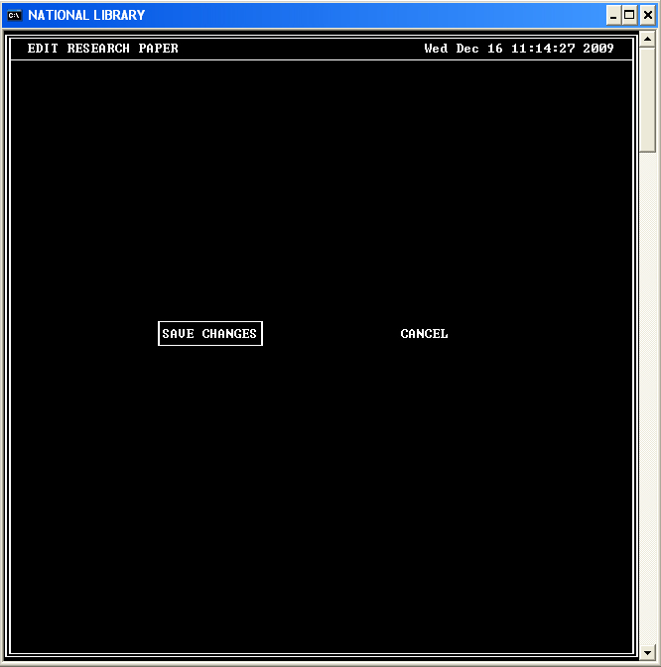

If the user confirms that they want to save the changes, the updated information will be stored and the changes will be displayed to the user.

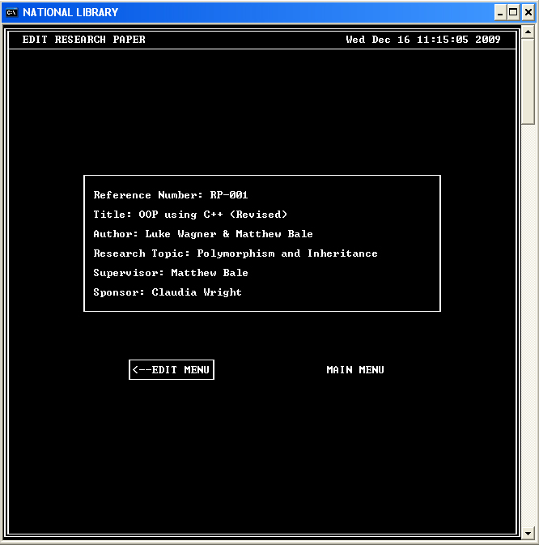

The user can then return to the “Edit Menu” to edit another material or return to the “Main Menu”.

Loan Menu

The user will be presented with the menu illustrated below if they select “LOAN” from the “Main Menu”.

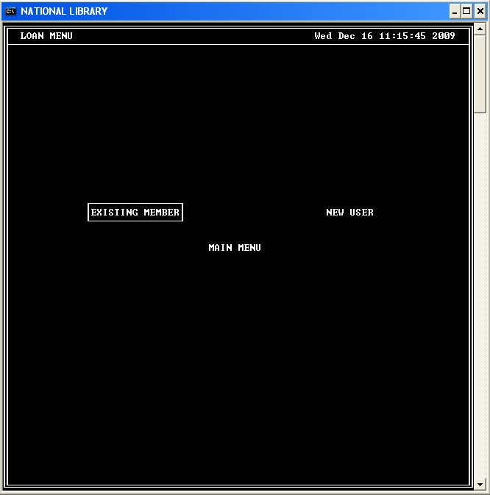

You must have a valid user ID in order to create a loan so the user should select “NEW USER” from this menu to register a new user if one has now already been created.

If the user chooses to register a new user, the form below will be presented to them.

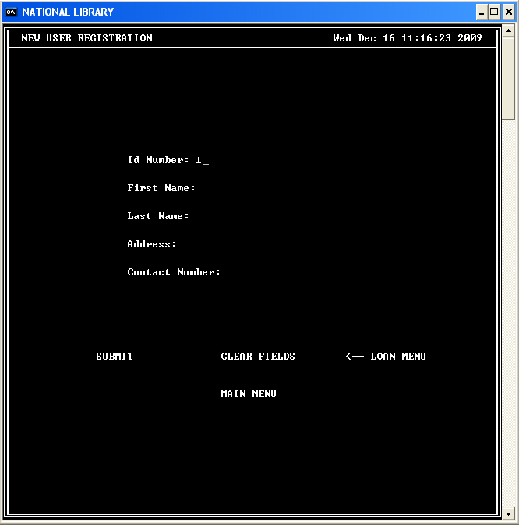

The value for the ID Number field is automatically generated for the user.

I the user complete the form, as shown in the example below.

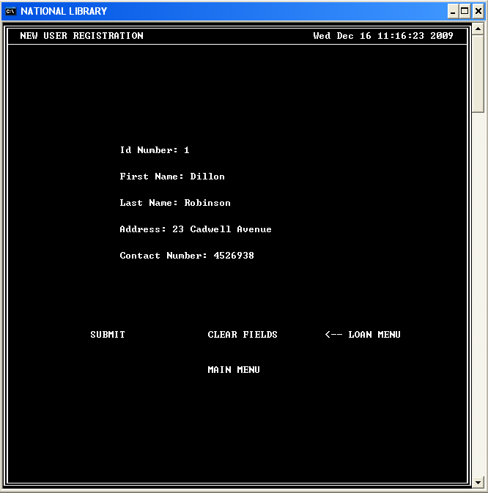

They will be able to select one of the options below the form.

If they choose to submit the data, they will be presented with an option to confirm their action or to cancel.

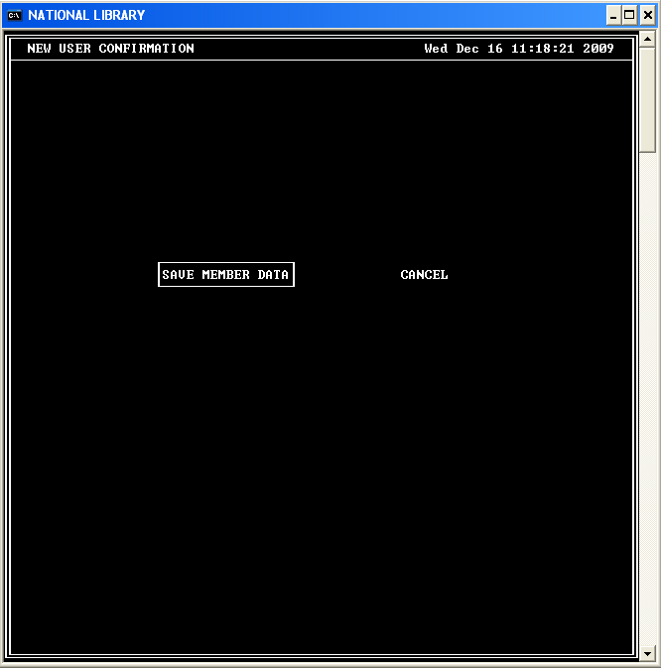

By selecting “SAVE MEMBER DATE”, the data entered will be saved and displayed to the user as illustrated below.

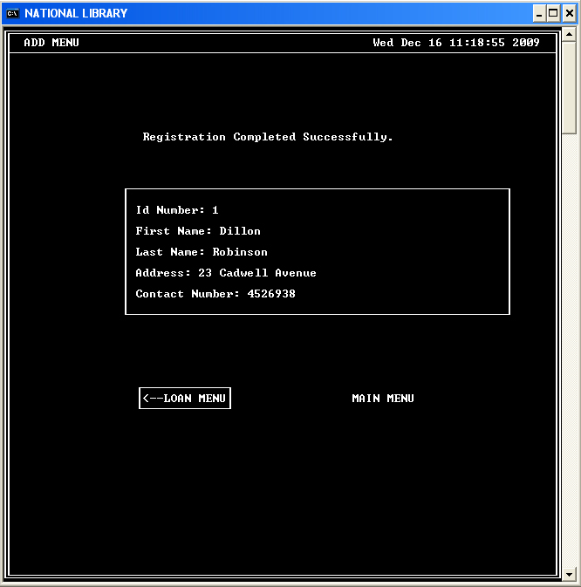

The user can then return to the “Loan Menu” or to the “Main Menu”.

Upon returning to the “Loan Menu”, the user will once again be presented with the option of registering new user or to loan a reference material to an existing user by selecting “EXISTING MEMBER” from the menu show below.

After selecting to loan to an existing member, the user will be presented with the following form.

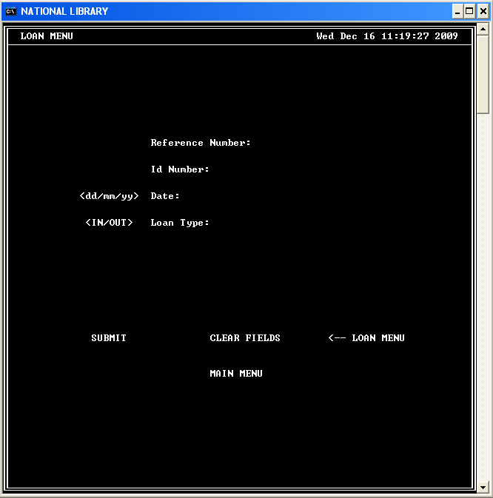

Upon completing the form:

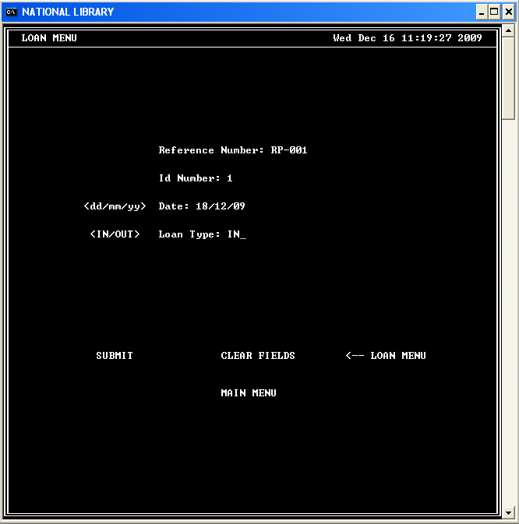

The confirmation menu will be shown to the user.

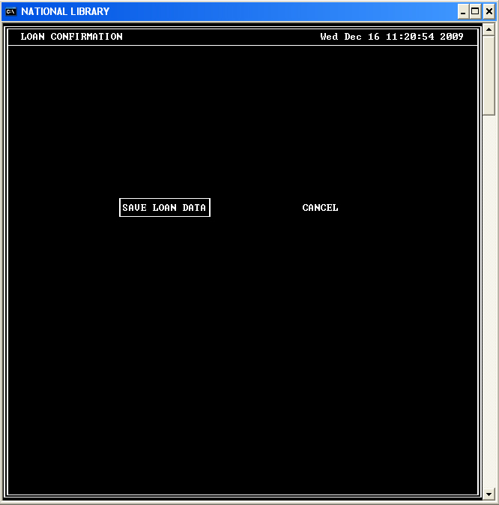

By confirming to save the loan data, the data will be saved and displayed to the user.

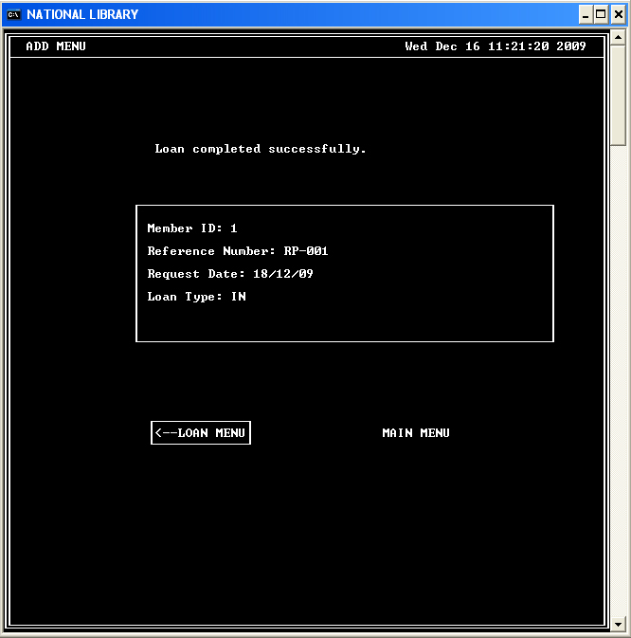

The user can then choose to return to the loan menu or to return to the main menu.

Return Menu

By selecting “RETURN” from the “Main Menu”, the user will be presented the form shown below.

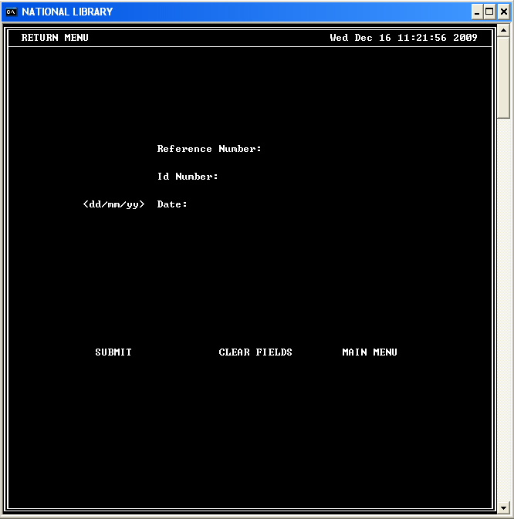

Upon filling the form with valid information:

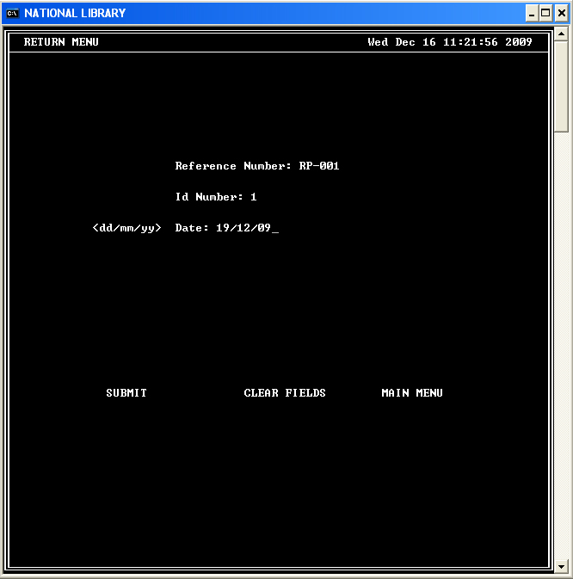

The user will be prompted to confirm their action or to cancel.

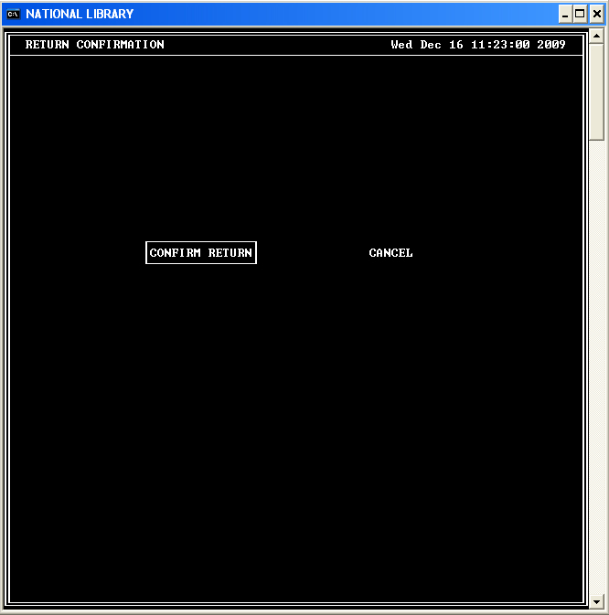

If the user chooses to return the loaned material, the information will be updated and the user will be shown the following screen.

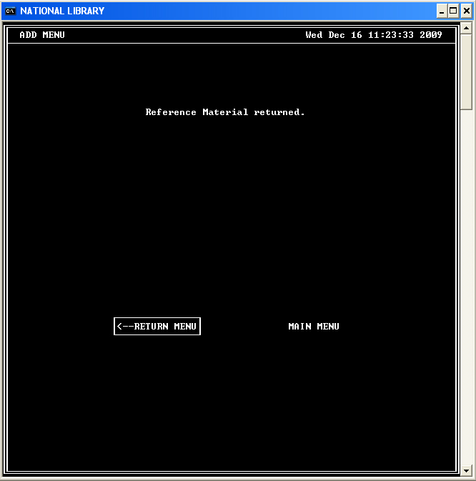

The user can then go to the “Return Menu” to return another loaned material or to go to the “Main Menu”.

Exit

If the user selects “Exit” from the “Main Menu”, the following options will be presented.

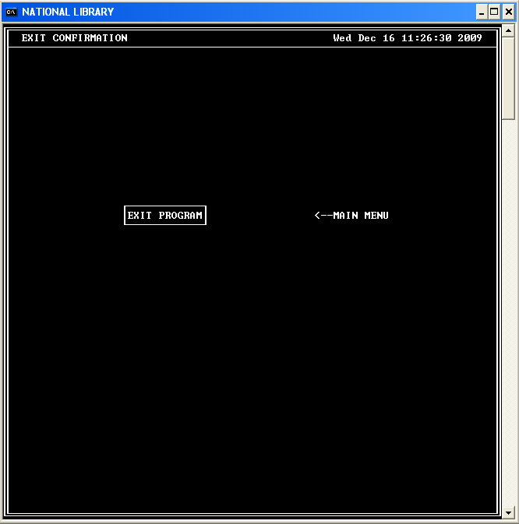

“EXIT PROGRAM” will end the program and “MAIN MENU” will take the user back to the “Main Menu”.

